**E-Commerce Website Testing**

**Test Plan**

**Test Plan Overview:**

**Project Name**: E-Commerce Website Testing  
**Objective**: Validate the functionality, usability, and security of an e-commerce website.  
**Scope**:

* Login functionality
* Product search
* Adding items to the cart
* Checkout and payment process

**Test Environment:**

* Browsers: Chrome, Safari, Edge
* Devices: Desktop, Mobile
* Tools: JIRA, Zephyr, BrowserStack

**Test Deliverables:**

* Test Cases
* Test Execution Report
* Defect Log

**Risks:**

* Limited testing time on BrowserStack.
* Dynamic changes in the product catalog during testing.

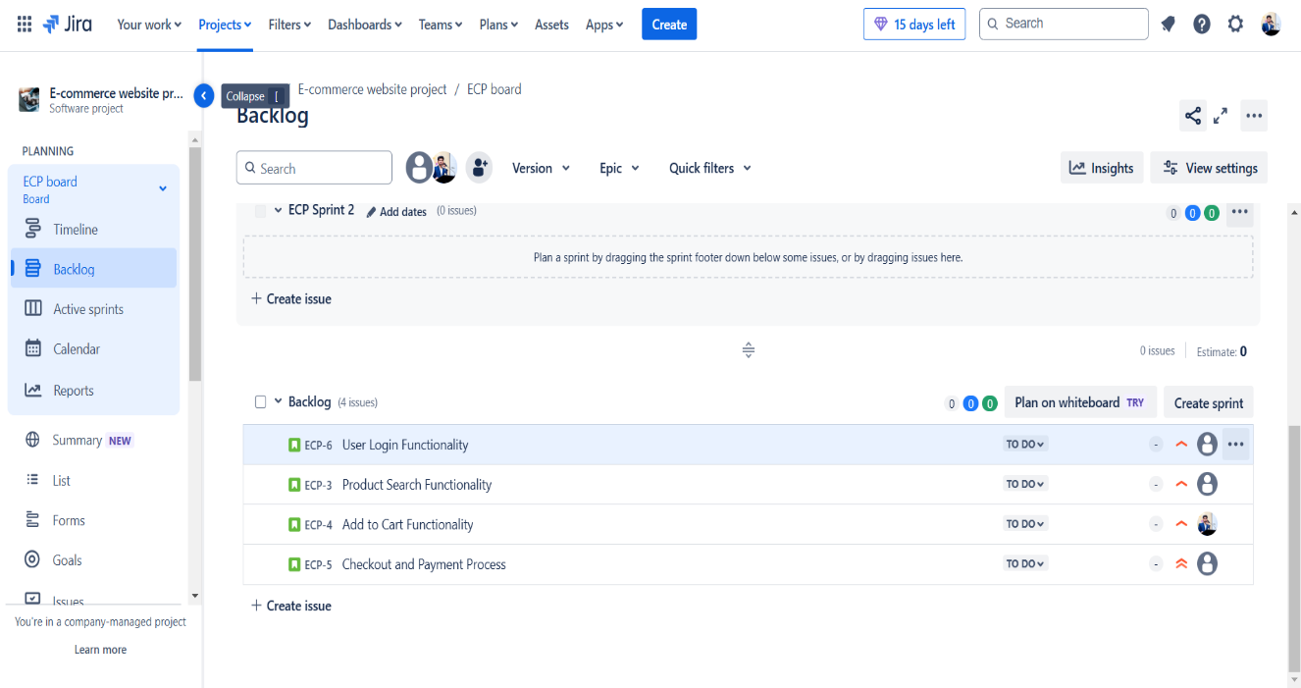

* ECP-2 User Login Functionality.

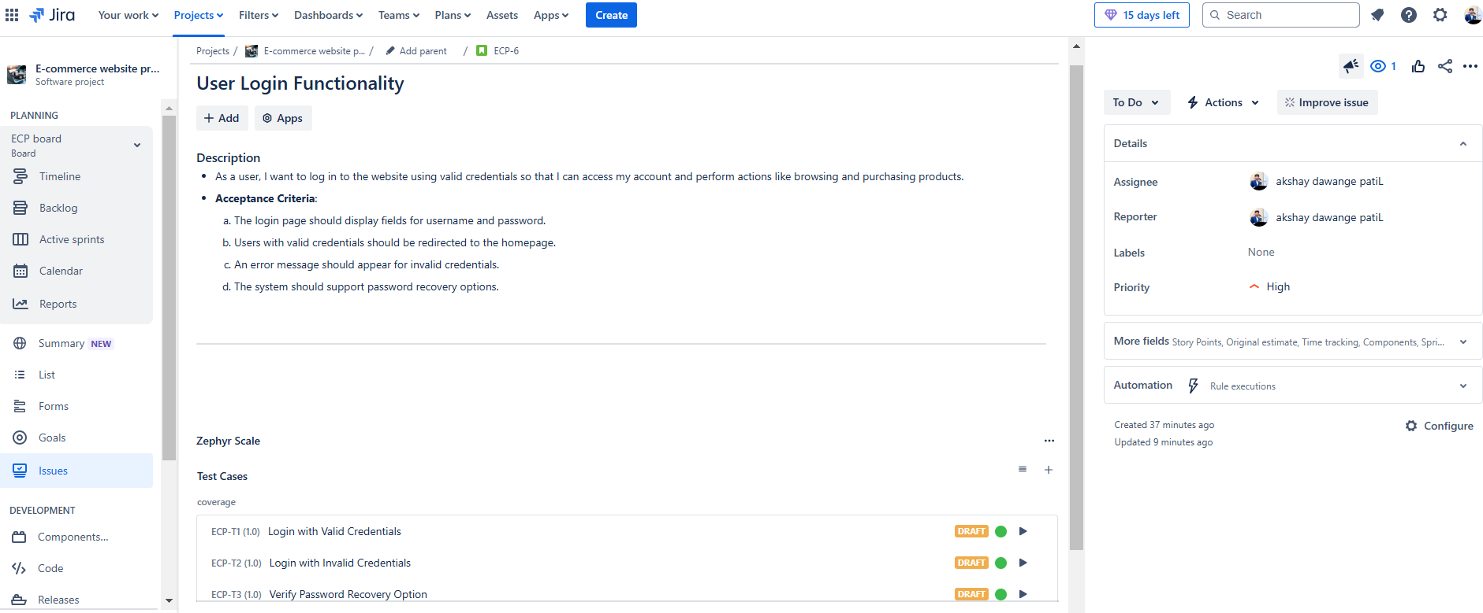

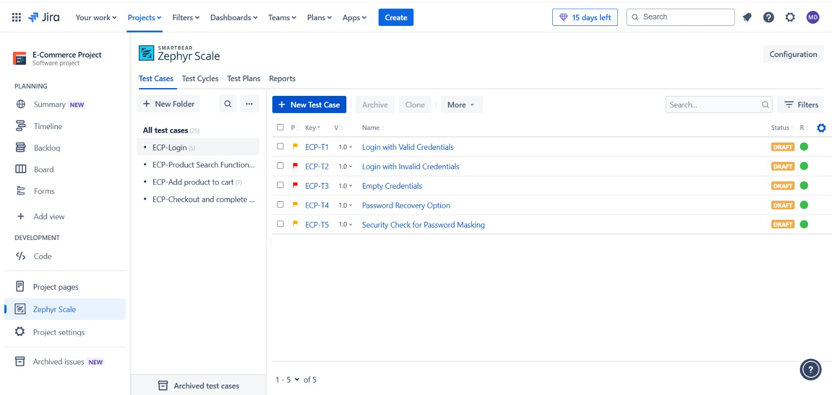

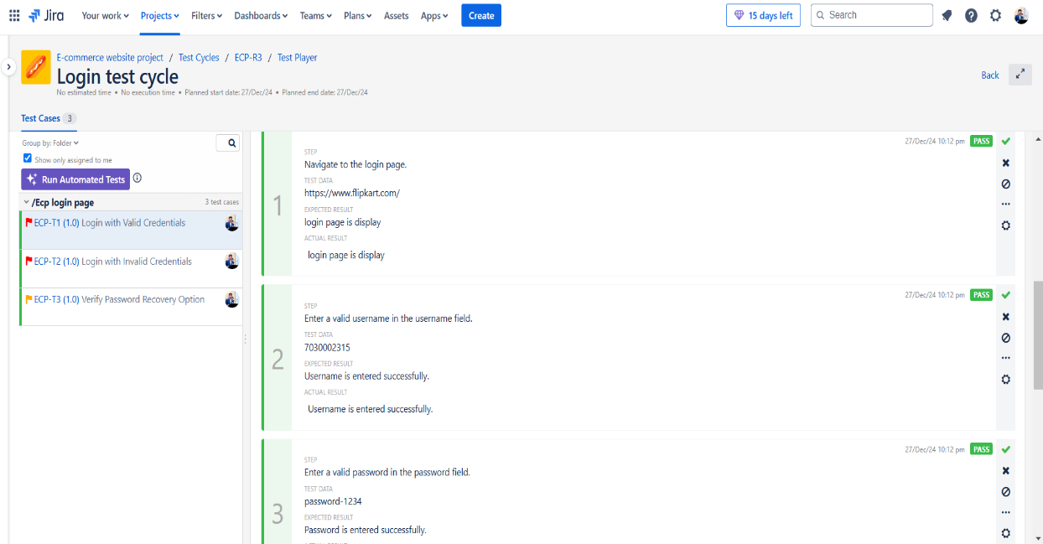

**ECP-3 Product Search Functionality**

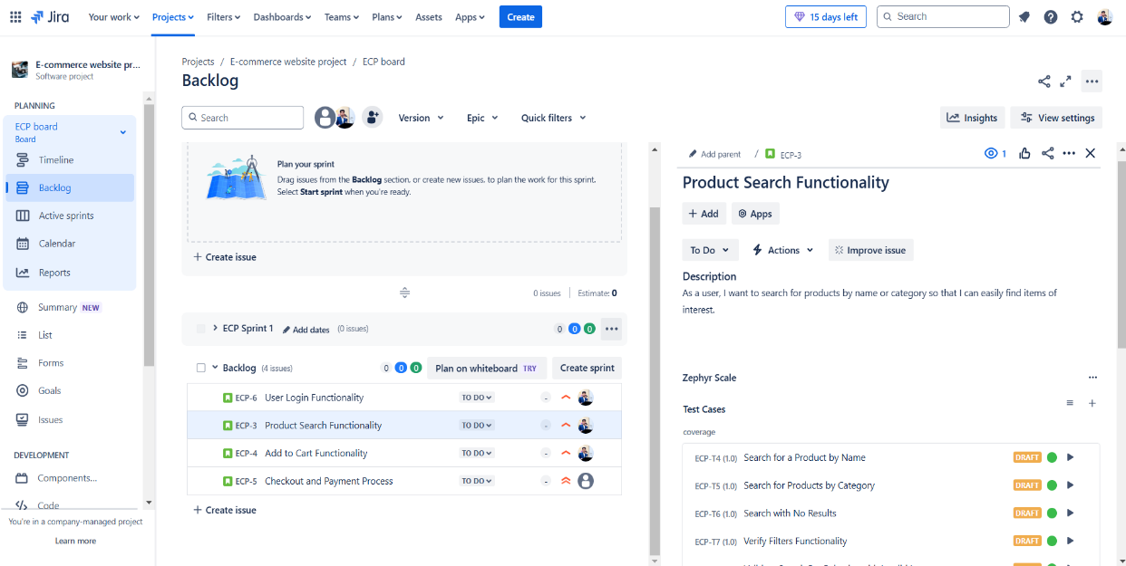

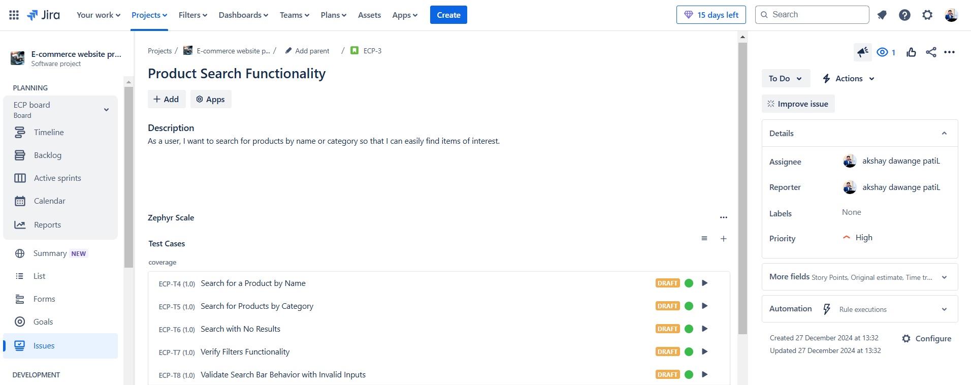

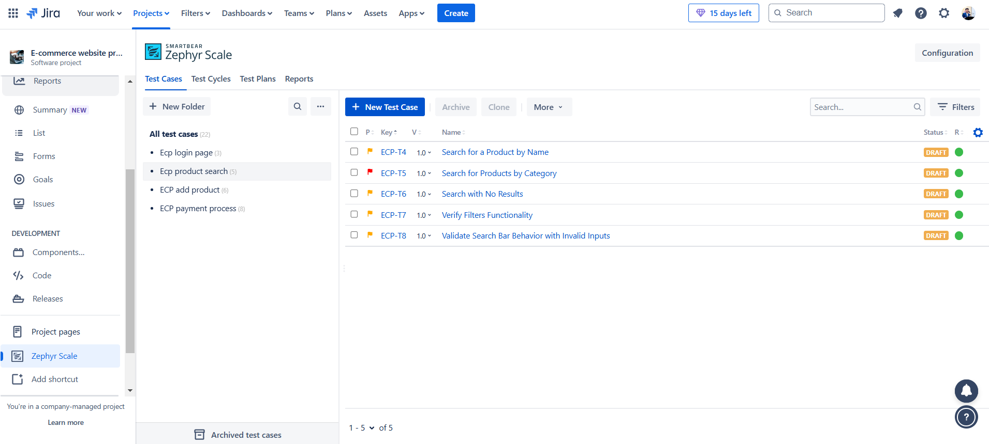

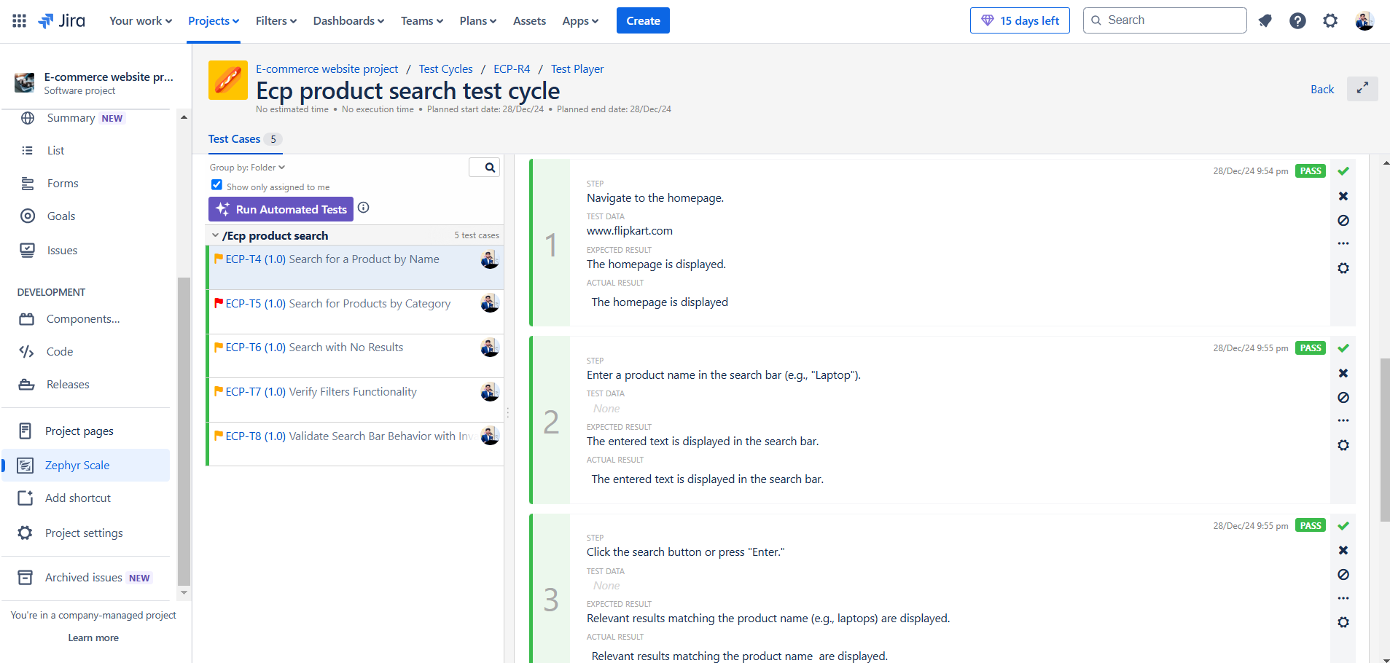

**ECP-4 Add to Cart Functionality**

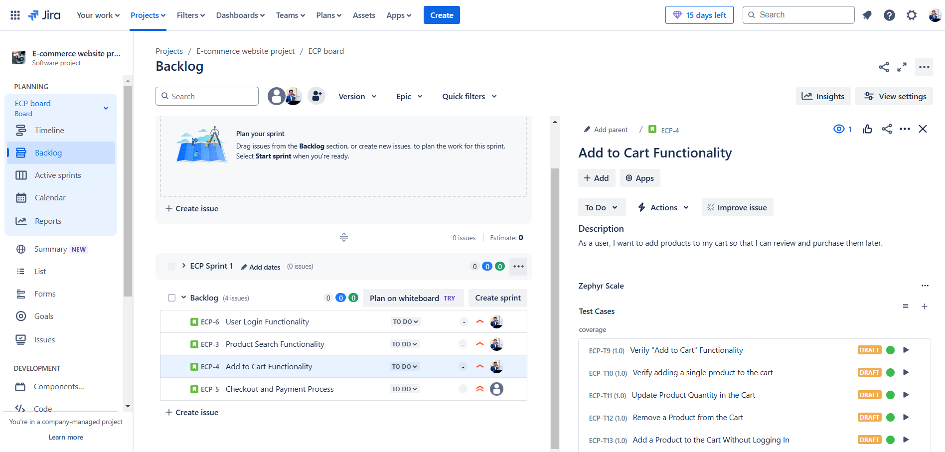

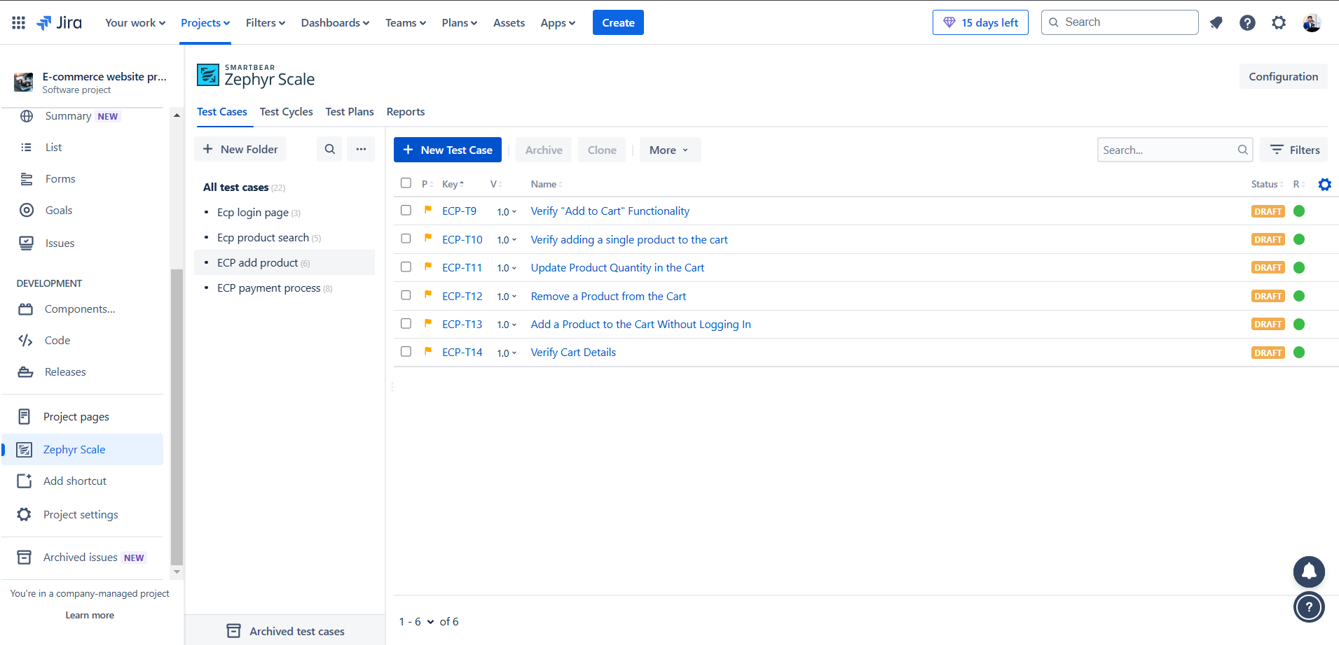



**ECP-5 Checkout and Payment Process.**

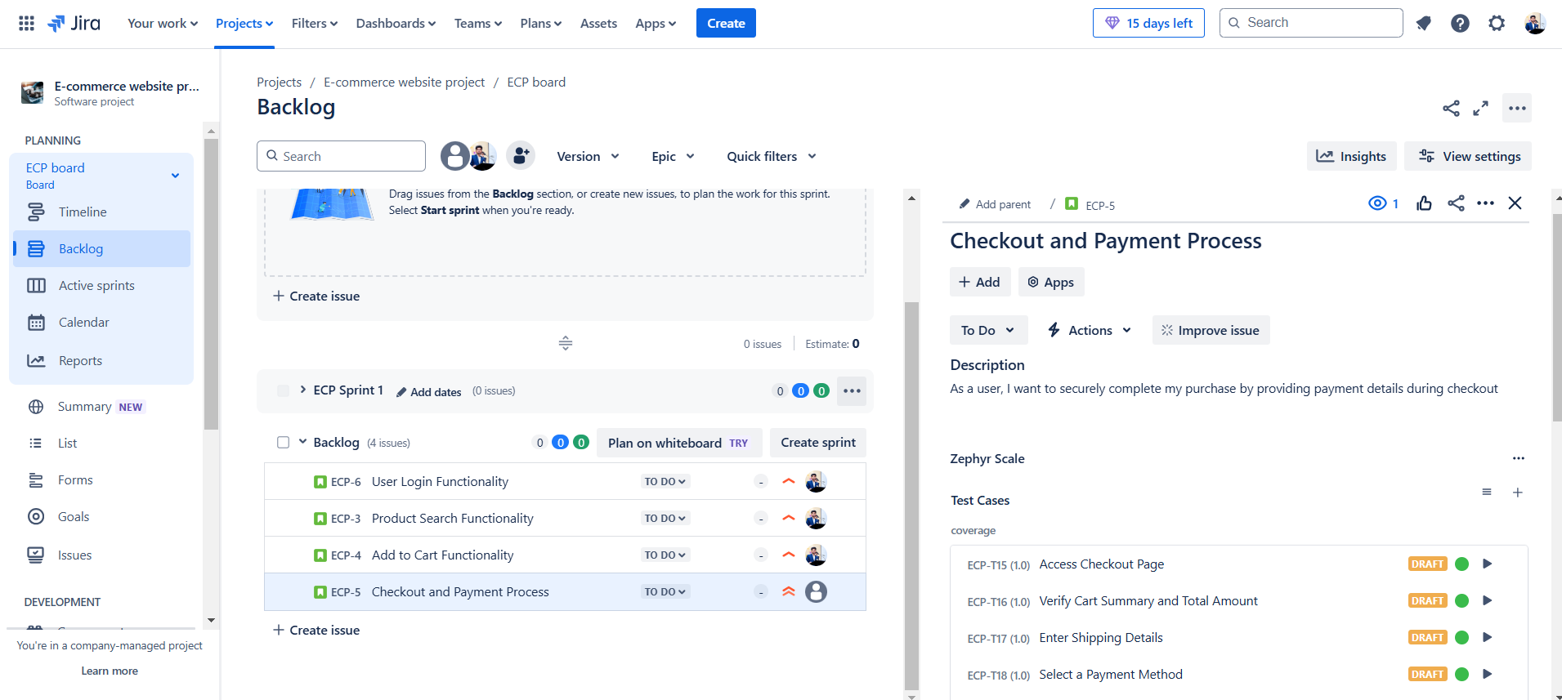

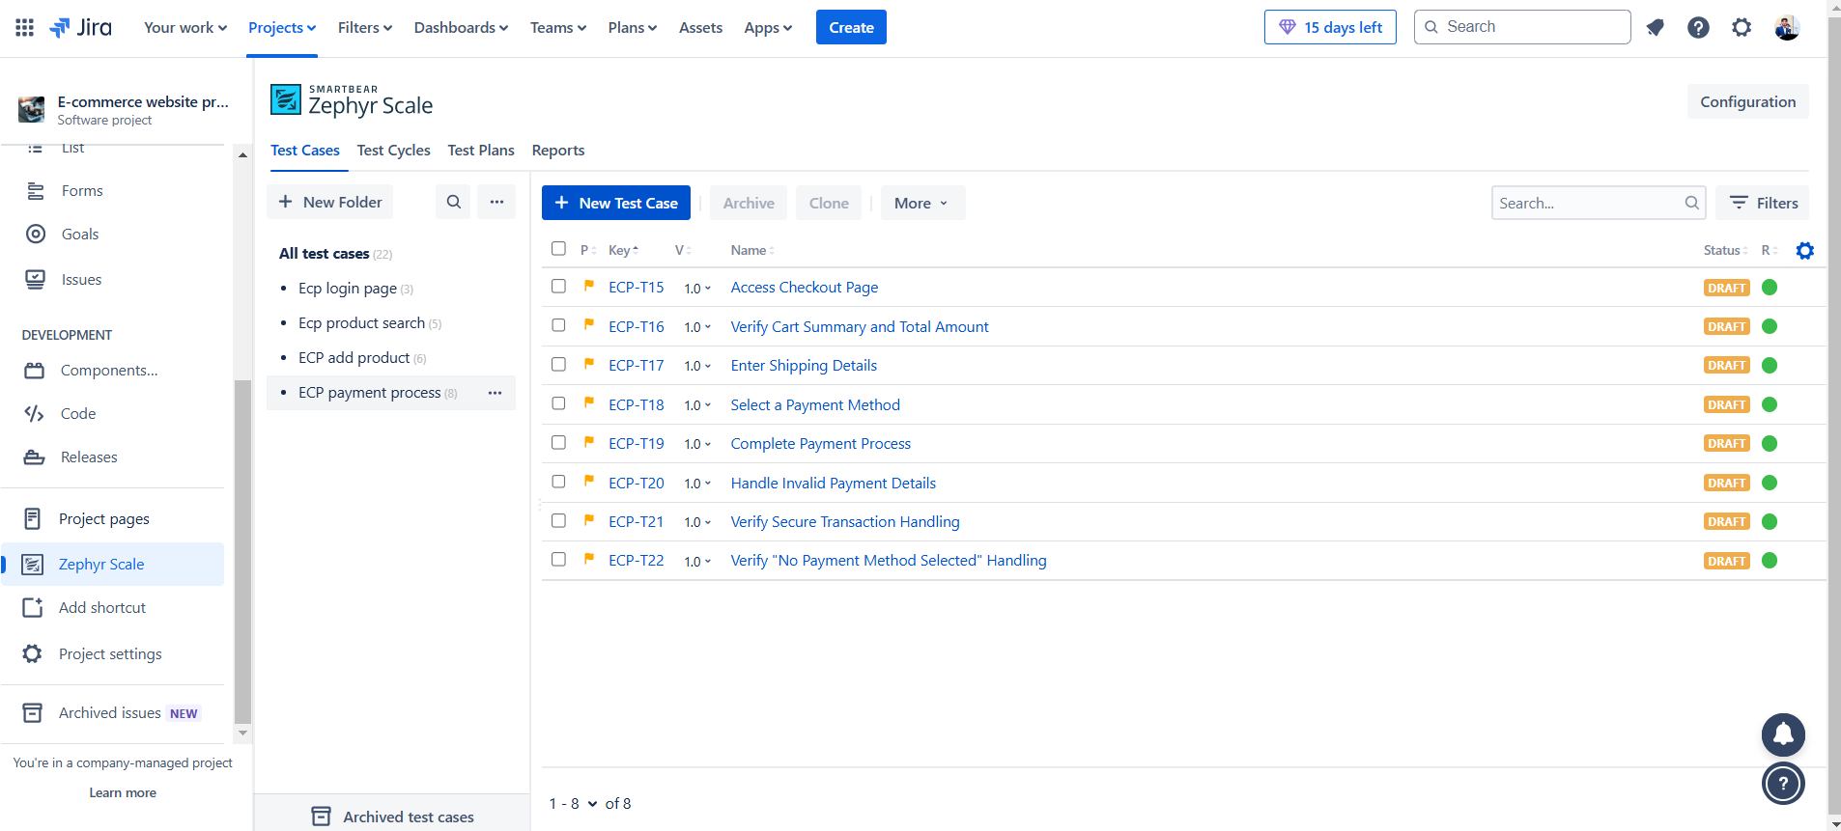

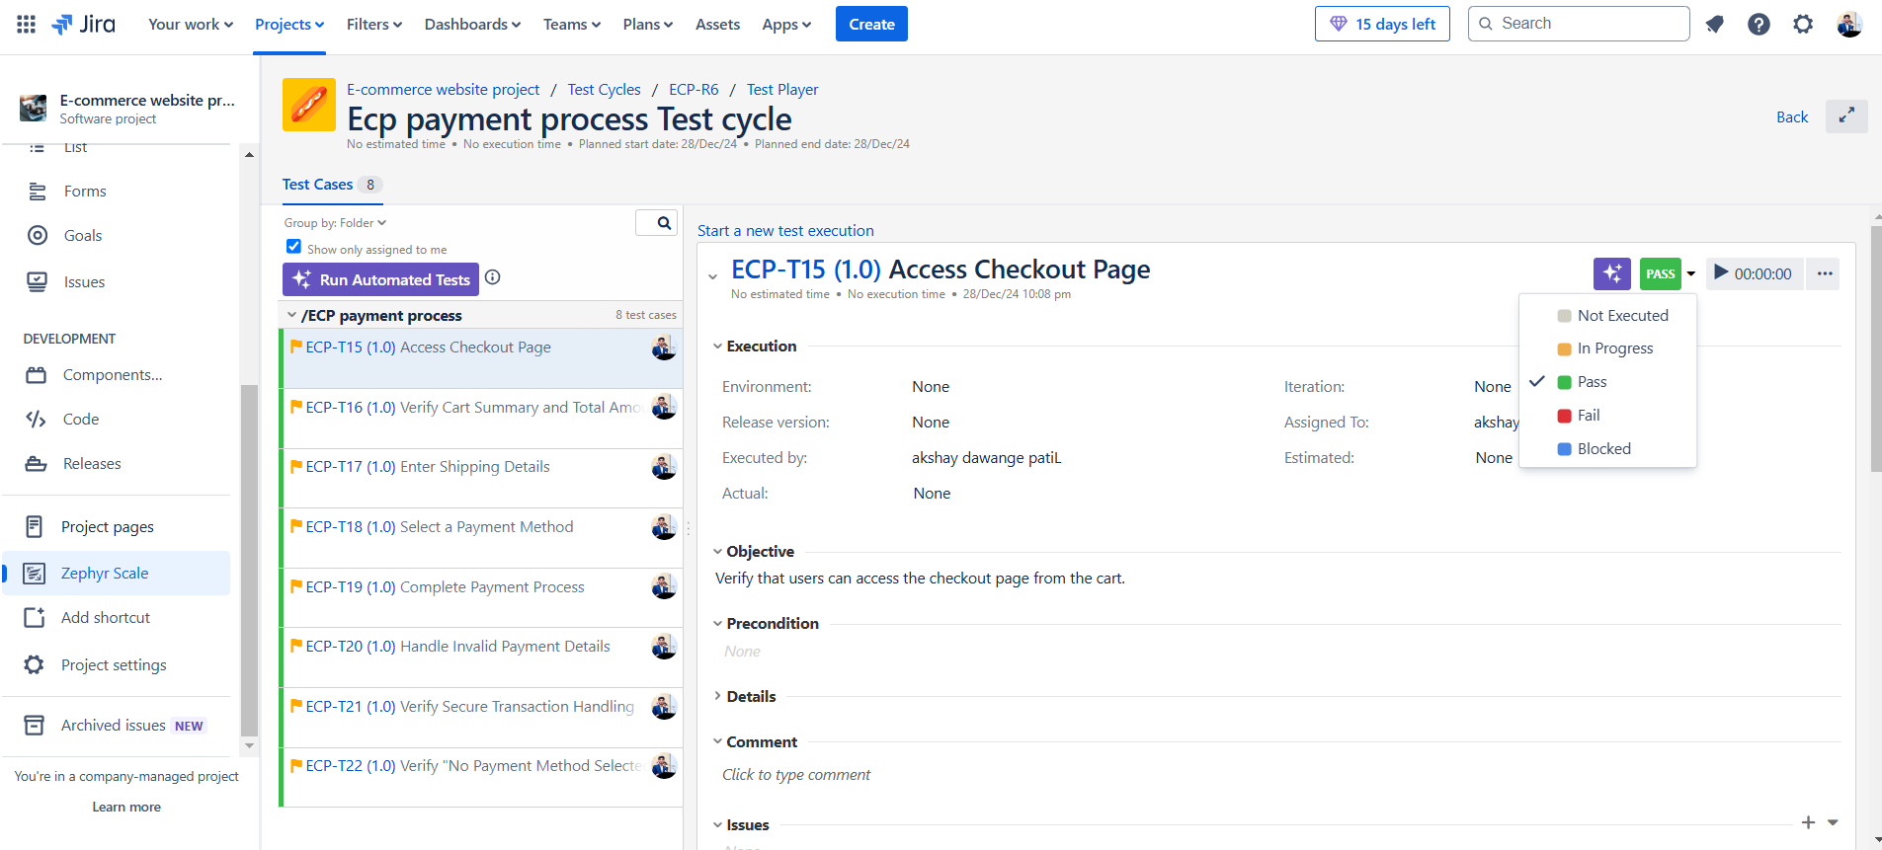

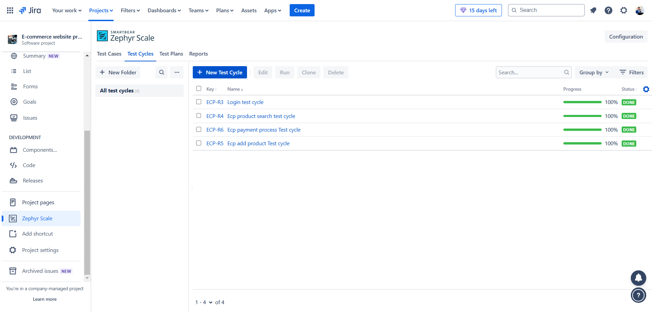

**Requirement Traceability Matrix (RTM)**

| **Requirement ID** | **Requirement Description** | **Test Case ID** | **Test Status** |
| --- | --- | --- | --- |
| R1 | Login with valid credentials | TC1 | Passed |
| R2 | Search for a product by name | TC2 | Passed |
| R3 | Add items to the cart | TC3 | Passed |
| R4 | Complete payment using a credit card | TC4 | Passed |

**Test Cases**

**Functional Test Cases**

| **Test Case ID** | **Test Case Description** | **Steps** | **Expected Result** | **Status** |
| --- | --- | --- | --- | --- |
| TC1 | Login with valid credentials | 1. Open website 2. Enter valid username and password 3. Click Login | User is redirected to the homepage | Passed |
| TC2 | Search for a product | 1. Enter product name in the search bar 2. Click Search | Relevant products are displayed | Passed |
| TC3 | Add item to cart | 1. Select a product 2. Click Add to Cart | Product is added to the cart | Passed |
| TC4 | Checkout and payment | 1. Go to cart 2. Click Checkout 3. Enter payment details 4. Confirm payment | Order is successfully placed | Passed |

**Security Testing Checklist**

| **Area** | **Security Test** | **Result** |
| --- | --- | --- |
| Authentication | Test login with invalid credentials | Passed |
| Authorization | Test restricted pages without login | Passed |
| Data Protection | Verify sensitive data is encrypted (e.g., passwords) | Passed |
| Session Management | Test session timeout and cookie expiration | Passed |